Agenda

AWS-DevOps

AWS
DevOps
DevSecOps
AWS-DevOps

AWS:
Launch a website:
Physical server
Storage
Networking equipment
Database
Electricity supply

AWS services:
EC2
S3
RDS
VPC
IAM
Lambda

Why do companies use AWS:
1.Scalability
2.Pay-as-you-go
3.Global infra
4.Managed services

DevOps:
Development + Operations

Developer-> writes code->”done”->Operationd->deploy the app

Devops lifecycle:
SDLC 6-7 phases

plan->code->build->test->deploy->maintenance

Devsecops:
Development+security+operations

code->build->test->security ->deploy

Devsecops approach:
plan->code (security checks)->build (security checks)->test
(security checks)->deploy (security checks)

Shift left security

AWS-DevOps:
Using aws cloud services and devops practices together to
Build,test,deploy an application automatically

Diff tools
github->store code
jenkins->ci/cd pipeline
docker->container
k8s->run app
aws->infra
Cloud watch-> monitoring

Problems:
1.too many integration
2.diff tools have diff configurations
3.diff dashboards

Benefits of aws-devops:

1.automation
Push code->build->test->deploy
Github, jenkins

Code pipeline,codecommit,code deploy,code build

2.faster software delivery

3.better collaboration

4.maintenance
Aws

1.code-commit
-private git repository
-managed by aws
-store your source code
-connect with ec2
-public repo cannot be created

2.codebuild
-fully managed build and test services provided by aws
Source code-> html, css and js,python—-->

Convert source code into something that is ready to be deployed

app.py
Html
Css
readme.md

-install dependencies
-compile the code
-run tests
-generate deployment files

Why do we need code build:
Login.java
User.java
Payment.java

Server ->raw .java files

.jar files-> can be deployed

What happens inside codebuild:
developer->git repo->aws code build->install dependencies->build->
test->package ->artifacts->s3

How does codebuild know what commands to execute:

Buildspec.yml
-configuration file
“During the build, what exactly should you do?”

Yaml:

Phases:
Install
Build
Artifacats

my_projects->html,css
|
Buildspec.yml, appspec.yml

1.Artifacts:
Output produced by the build process that you want to pass to the deployment stage

myapp.jar->
Application.zip

Where do we store our artifacts:
codebuild->artifacts->s3
S3 acts as a storage location for the build output

Can an artifacts contain multiple file?

Code-deploy:
Souce code->code build->artifacts

To deploy the application on server we need code deploy
-automates deployment process
-ec2,lambda

It takes our application artifacts and puts it onto the target serve,
Then performs the deployment steps we define

Appspec.yml
Instruction for codebuild
-application specification file used by code deploy to define
Deployment instruction

Which file to copy
Where to copy them
What scripts to run

developer->git repo->aws code build->install dependencies->build->
test->package ->artifacts->s3->codedeploy->ec2

AWS codepipeline:
-continuous delivery service that automates the movement of your
Application through different stages of your software delivery process
build->test->deploy
Similar to jenkins
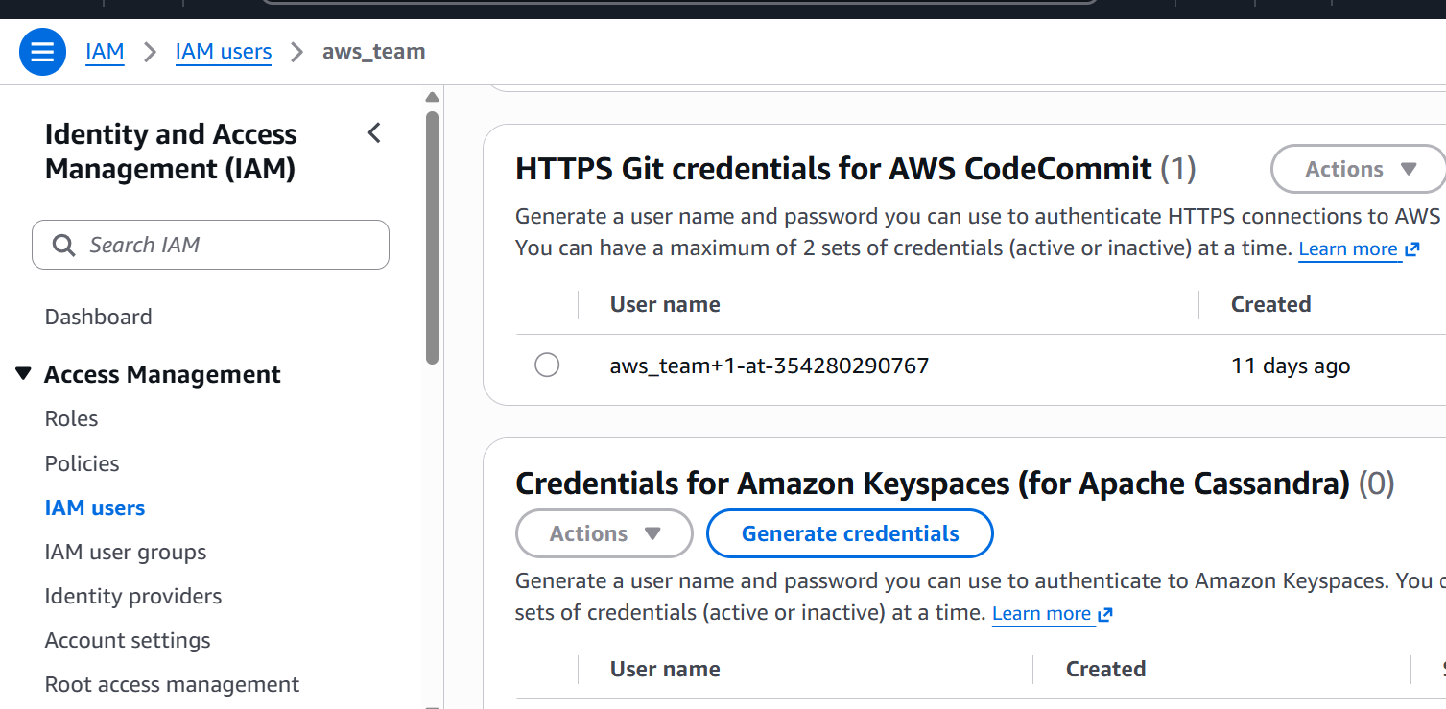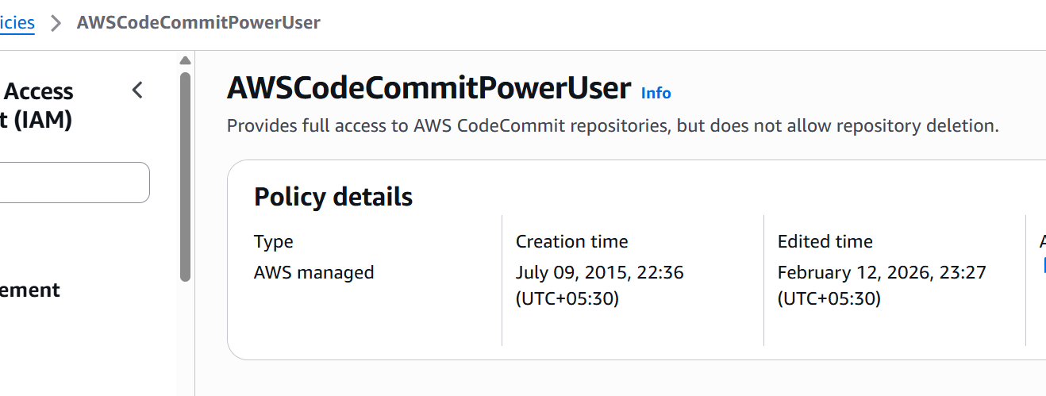

Hands-on 2
Repo
Index.html
Appsec.yml
buildspec.yml
script->dir
|
Install_nginx.sh and start_nginx.sh

Build the code
Create the artifacts in s3
Deploy the code on ec2
Create a pipeline for everthing

buildspec.yml
version: 0.2

phases:
install:
commands:
- echo "Install phase"

pre_build:
commands:
- echo "Pre-build phase"
- ls -la

build:
commands:
- echo "Build phase started"
- mkdir -p build
- cp index.html build/
- chmod +x script/*.sh

post_build:
commands:
- echo "Build completed"
- ls -R

artifacts:
files:
- appspec.yml
- script/**/*
- build/**/*

Appspec.yml
version: 0.0

os: linux

files:
- source: /
destination: /var/www/html

file_exists_behavior: OVERWRITE

permissions:
- object: /var/www/html
pattern: "**"
owner: www-data
group: www-data
mode: 755
type:
- file
- directory

hooks:
BeforeInstall:
- location: script/install_nginx.sh
timeout: 300
runas: root

ApplicationStart:
- location: script/start_nginx.sh
timeout: 300
runas: root

